**Topic:** Myanmar Culture

**EQ: How does our website help foreigners to impress Myanmar culture and**

**traditions?**

**Color scheme: white, black, moccasin, lemonchiffon, navajowhite, chocoate, sandybrown, blue, aqua, grey, burlywood**

**Font style: Calibri, Stika, Times New Roman**

**Wireframe** (At least one wf for homepage) : screenshots

Home page (details) (for only important pages)

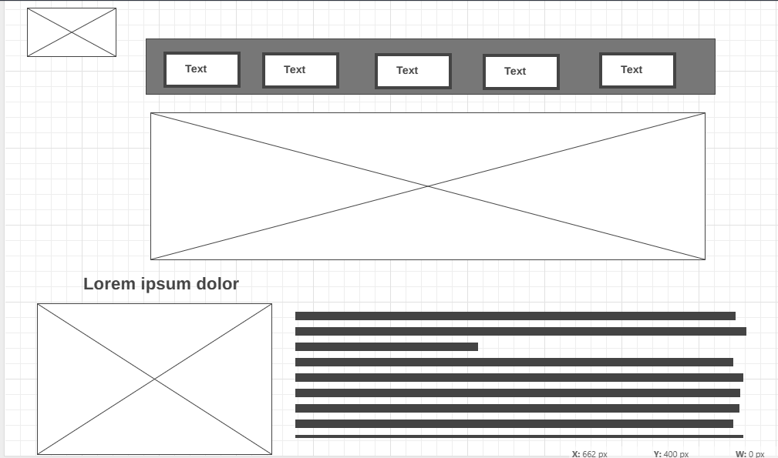

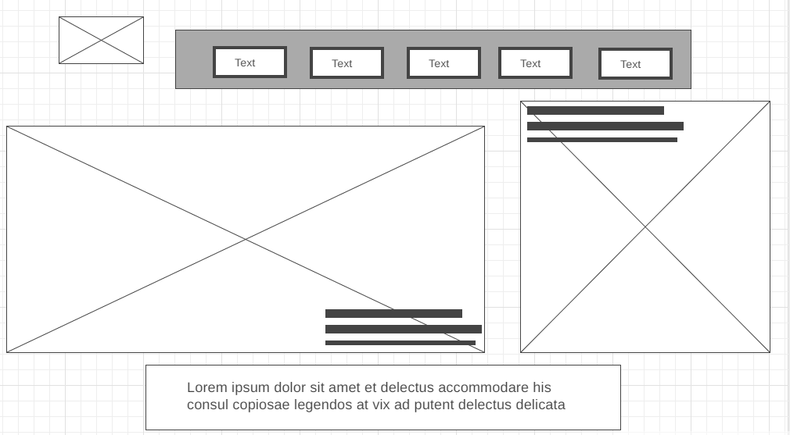



**Ref Links:**

* YouTube:

[Create a form with Google HTML service and submit data to Google Sheets.](https://youtu.be/VJ3u9Hv97YE)

* Google:

<https://www.google.com/maps?authuser=0>

* Website and Images

Myanmar Alphabets

https://sydneylanguagesolutions.com.au/blogs/myanmar-language/

Myanmar Numbers

http://www2.hawaii.edu/~hlibcat/documents/2F03993D1C7C8757D7E191B151DA82EEF72E7727.html

Buddhist

https://www.kimkim.com/c/explore-buddhism-in-myanmar-15-days

Islam

https://www.ucanews.com/news/myanmar-muslims-mute-on-rohingya-amid-fear-of-violence/81800

Christian

https://www.persecution.org/2021/03/16/christians-participation-military-coup-myanmar/

Hindu

https://www.facebook.com/WorldwideHinduTemples/photos/beautiful-kali-bari-temple-at-konzaytan-street-yangon-myanmar-burma/1032094223603105/

Animist

https://en.wikipedia.org/wiki/Nat_%28deity%29

Panbel

https://www.mdn.gov.mm/my/mnmaariuraa-pnpailkmupnnyaa-lupngnttngkymuriseaalnny-pnnyaalkchngkm-sngyuuliusuu-mittmiuttng

Panyun

https://my.wikipedia.org/wiki/%E1%80%95%E1%80%94%E1%80%BA%E1%80%B8%E1%80%9A%E1%80%BD%E1%80%94%E1%80%BA%E1%80%B8

Panbu

https://my.wikipedia.org/wiki/%E1%80%95%E1%80%94%E1%80%BA%E1%80%B8%E1%80%95%E1%80%AF

Panpoot

https://www.wikiwand.com/my/%E1%80%95%E1%80%94%E1%80%BA%E1%80%B8%E1%80%95%E1%80%BD%E1%80%90%E1%80%BA#Media/%E1%80%96%E1%80%AD%E1%80%AF%E1%80%84%E1%80%BA:Pindaya-Schirme-10-Drechseln-gje.jpg

Pantin

https://old.mmload.com/news/48530

Myanmar Nationality

https://www.newmandala.org/wp-content/uploads/2017/04/National-races.jpg

kyaiktiyo

https://www.istockphoto.com/photos/kyaiktiyo-pagoda

mrauk-u

https://www.alanthology.com/content/images/2022/05/Mrauk-U-The-Forgotten-Paradise-Of-Myanmar-1.jpeg.webp

sri_ksetra

https://www.pinterest.com/pin/baw-baw-gyi-pagoda-sri-ksetra--319474167293020838/

hanlin

https://myanmarmotorbikes.com/wp-content/uploads/2018/09/upper-myanmar-tour-09.jpg

beikthano

https://upload.wikimedia.org/wikipedia/commons/3/3f/Gate_of_Beikthano_Historical_Sites.jpg

inwa

https://youimg1.tripcdn.com/target/100o1f000001gp47e44CA.jpg?proc=source%2Ftrip

mahamuni

https://i.pinimg.com/originals/59/28/02/5928025d7bb225385e5199e0927ec9db.jpg

mandalay

https://www.mandalayintlairport.com/sites/default/files/mandalay-hill.jpg

kuthodawhttps://media.worldnomads.com/Explore/myanmar/inle-lake-fishermen-istock.jpg

https://evivatour.com/wp-content/uploads/2021/09/Kuthodaw-Pagoda-in-Mandalay-1000x565.jpg

inlay

https://media.worldnomads.com/Explore/myanmar/inle-lake-fishermen-istock.jpg

pindaya

https://www.go-myanmar.com/pindaya

bagan

https://www.telegraph.co.uk/content/dam/Travel/leadAssets/26/34/bagan_2634180a.jpg

burma_costume

<https://www.pinterest.com/pin/502644008394786294/>

chin_costume

<https://www.pinterest.com/pin/232357662014559741/>

kachin_costume

<https://www.pinterest.com/pin/628604060461175969/>

mon_costume

<https://www.pinterest.com/pin/999588079763680616/>

karen_costume

<https://twitter.com/kywa_kyaw/status/814429947800403969>

kayah_costume

<https://www.myanmars.net/people.html>

rakhine_costume

<https://www.pinterest.com/pin/735353445383845752/>

shan_costume

<https://www.pinterest.com/pin/253538654002078406/>

kason

<https://www.myanmardigitalnewspaper.com/en/full-moon-day-kasone-buddha-day>

waso

<https://www.celebratedmyanmar.com/seasonal-festival/festivals-july/>

wagaung

<http://student-id-2026.pagemyanmar.com/fes.php?month=5#1>

tawthalin

<https://steemit.com/myanmar/@pyaesonekhinkhin/yamnmayaoyaundefinedtathlnglelwyapi-ngpye-201793t25854740z>

thadingyut

<https://www.myanmore.com/2013/10/thadingyut-festival/>

tazaungmon

<https://www.tachileik.net/mm/2018/11/kh2018.html>

nataw

<http://www.timeayeyar.com/2016/12/blog-post_722.html>

pyatho

<http://student-id-2026.pagemyanmar.com/fes.php?month=10>

tabodwe

<https://tourism.gov.mm/mm/february-festivals/htamane-festival/>

tabaung

<https://tourism.gov.mm/mm/february-festivals/htamane-festival/>

taungshay

<https://br.pinterest.com/pin/832040099928605648/>

thaimathein

<https://my.wikipedia.org/wiki/%E1%80%91%E1%80%AD%E1%80%AF%E1%80%84%E1%80%BA%E1%80%99%E1%80%9E%E1%80%AD%E1%80%99%E1%80%BA%E1%80%B8>

pawar

<https://www.shwengwegames.com/archives/55977>

htabi

<https://www.facebook.com/photo/?fbid=128791405761840&set=pcb.128792402428407>

lalkatone

<https://www.shop.com.mm/products/-i100460083.html>

pasoe

<https://www.shwengwegames.com/archives/44162>

tikepone

<https://www.shwengwegames.com/archives/44162>

gaungpaung

<https://www.facebook.com/photo/?fbid=2857683180942047&set=pcb.2857687467608285>

makite

<https://www.bbc.com/burmese/in-depth-48615814>

sepon

https://www.pinterest.com/pin/957577939493415624/

duyindaw

https://www.pinterest.com/pin/23503229297492746/

mahrlatr

https://maunghsunge.wordpress.com/2019/04/29/%E1%80%99%E1%80%9F%E1%80%9C%E1%80%B9%E1%80%9C%E1%80%90%E1%80%AC%E1%80%90%E1%80%94%E1%80%BA%E1%80%86%E1%80%AC%E1%80%9D%E1%80%90%E1%80%BA%E1%80%9B%E1%80%AF%E1%80%B6%E1%80%80%E1%80%BC%E1%80%AE%E1%80%B8/

khahtipr1

https://www.uabmarketplace.com/shop/empire-kttipapainatkyaasi-kala-anet-saok-10-2

khahtipr2

https://www.facebook.com/photo/?fbid=876974379018752&set=pcb.876974552352068

thayay1

https://my.wikipedia.org/wiki/%E1%80%8A%E1%80%BE%E1%80%95%E1%80%BA%E1%80%96%E1%80%AD%E1%80%94%E1%80%95%E1%80%BA

thayay2

https://www.facebook.com/photo/?fbid=2180735775482922&set=pcb.2180735975482902

golden_feather_hintha_bird_shoes

https://www.pinterest.com/pin/859765385127600150/

yinbone

https://www.facebook.com/102146325093015/photos/a.102150605092587/115183313789316/?paipv=0&eav=AfbqFiO1GEAqimIlfWHNpGLKu3vz8FzB2YzQbwqqL-cl_Y9NGSEDPyHFr372Q6Wckso&_rdr

https://www.pinterest.com/BurmeseCulture/burma-ornament/၄

hta_ma_nae

https://www.tastewindowmagazine.com/contributors/%E1%80%91%E1%80%99%E1%80%94%E1%80%B2/

glutinus_rice _ball

https://www.tastewindowmagazine.com/contributors/%E1%80%99%E1%80%AF%E1%80%94%E1%80%B9%E1%82%94%E1%80%9C%E1%80%B6%E1%80%AF%E1%80%B8%E1%80%B1%E1%80%9B%E1%80%B1%E1%80%95%E1%81%9A-glutinus-rice-ball/

mote_lin_ma_yr

https://www.facebook.com/2030988407122418/photos/a.2361739904047265/2631533787067874/

htan_ngat

https://myfoodmyanmar.com/health-benefits-of-palm-sugar/

hrlrwr

http://mmlazp.blogspot.com/2020/07/blog-post.html

mote_kyr_si

https://www.wutyeefoodhouse.com/?p=2568

mote_pound

https://www.foodindustrydirectory.com.mm/food-industry/cuisine/myanmar/item/1990-myanmar-snack-montepound.html

mote_kywl_thae

https://www.facebook.com/341864913016947/photos/%E1%80%99%E1%80%AF%E1%80%94%E1%80%B9%E1%82%94%E1%80%80%E1%81%BD%E1%80%BC%E1%80%B2%E1%80%9E%E1%80%B2-%E1%80%B1%E1%80%99%E1%80%B8%E1%80%B1%E1%80%94%E1%80%90%E1%80%B2%E1%80%B7-%E1%80%9E%E1%80%B0%E1%80%84%E1%80%9A%E1%80%B9%E1%80%81%E1%80%BA%E1%80%84%E1%80%B9%E1%80%B8%E1%80%99%E1%80%BA%E1%80%AC%E1%80%B8-%E1%80%99%E1%80%AF%E1%80%94%E1%80%B9%E1%82%94%E1%80%80%E1%81%BD%E1%80%BC%E1%80%B2%E1%80%9E%E1%80%B2-order-%E1%80%99%E1%80%BD%E1%80%AC%E1%80%9C%E1%80%AD%E1%80%AF%E1%82%94%E1%80%9B%E1%80%95%E1%80%AB%E1%81%BF%E1%80%95%E1%80%AE%E1%80%B1%E1%80%94%E1%80%AC%E1%80%B9-/501888930347877/?paipv=0&eav=Afa6N0IGtqDsfUQdeKYshpTbrp3RutoHsLzRv9gqPbR_cY-A5I8a9_DlKsEIZn_4hvg&_rdr

yo

https://www.facebook.com/photo/?fbid=104709928266582&set=pcb.104711631599745

black_sticky_rice

https://myansinenczed.tumblr.com/post/77947979752/mm-%E1%80%99-%E1%80%94-%E1%82%94%E1%80%80-%E1%80%9C-%E1%80%99-%E1%80%81-%E1%80%84-%E1%80%9E-%E1%80%80%E1%80%99-%E1%80%81%E1%80%90-%E1%80%84-%E1%80%9B-%E1%80%9C-%E1%80%9A